# Execution comments from HW6

1. Packages added:
   1. com.huangshotelreservation.view
      1. classes added:
         1. MessageDialog.java
         2. Utils.java
         3. ViewDriver.java
   2. com.huangshotelreservation.view.mainjframe
      1. classes added:
         1. MainJFrame.java
         2. MainJFrameController.java
   3. com.huangshotelreservation.view.seegalleryjframe
      1. classes added:
         1. SeeGalleryJFrame.java
         2. SeeGalleryJFrameController.java
2. Tests:
   1. No tests were added during this week.

No compiler error:

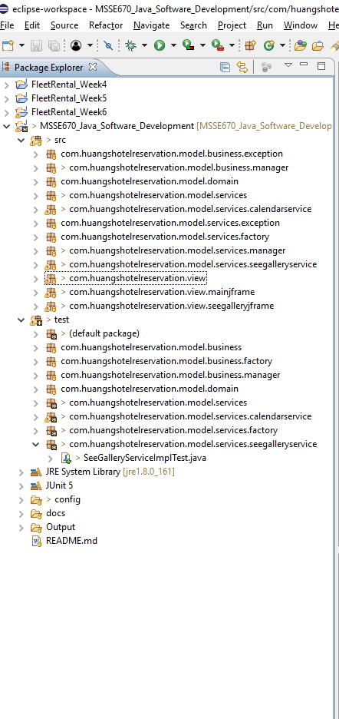

Mainframe of the presentation layer:

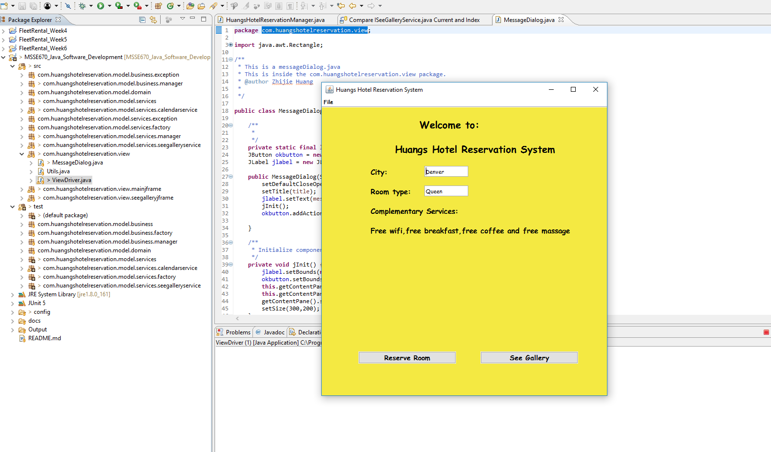

ReserveRoom(2nd highest priority use case, will be implemented)

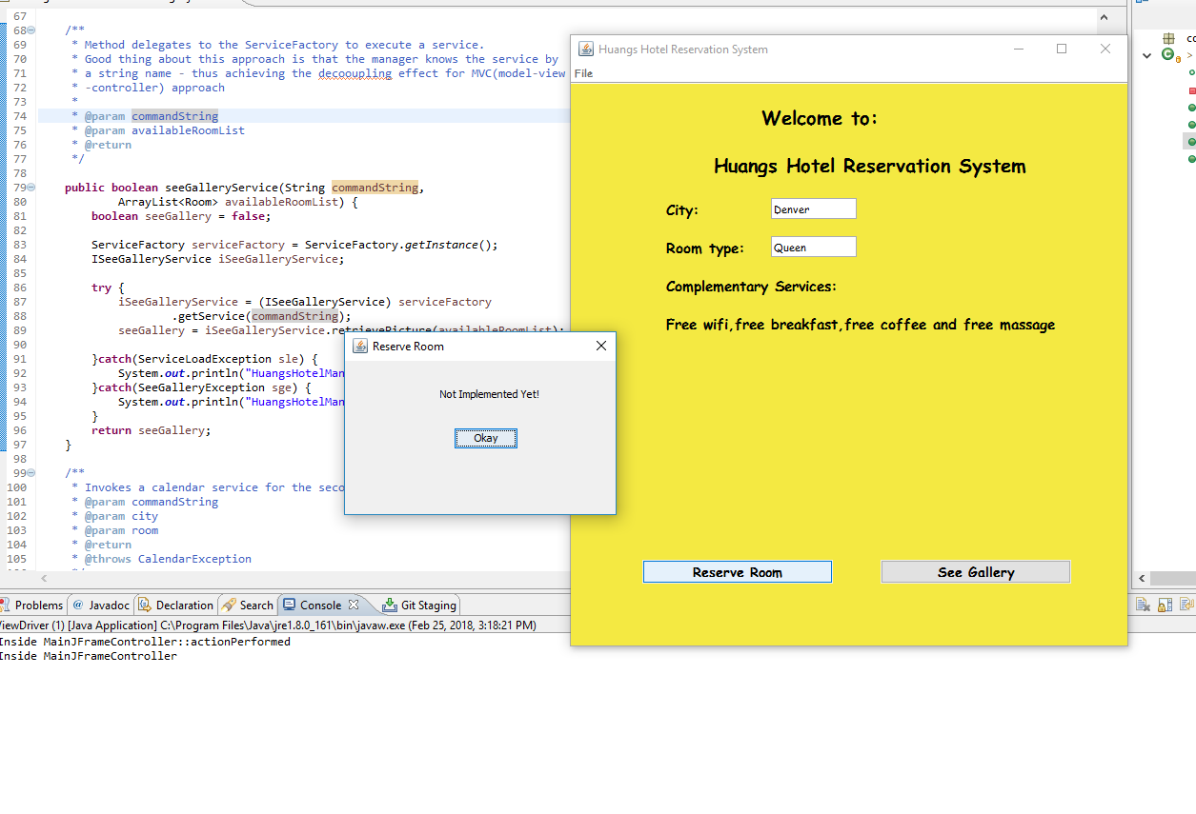

ISeeGalleryService(1st priority case):

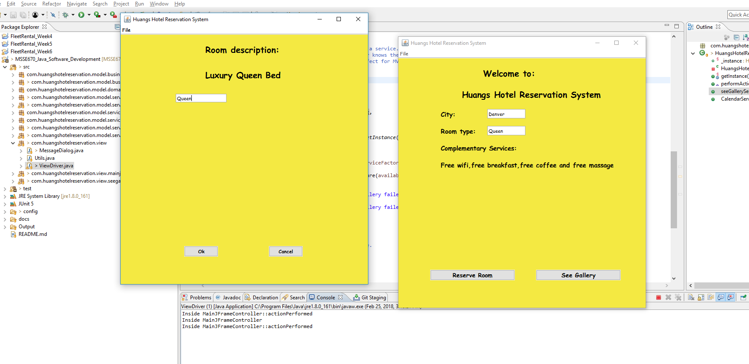

Successfully call the HuangsHotelReservationManager to load the correct service and return the correct successfully see gallery message.

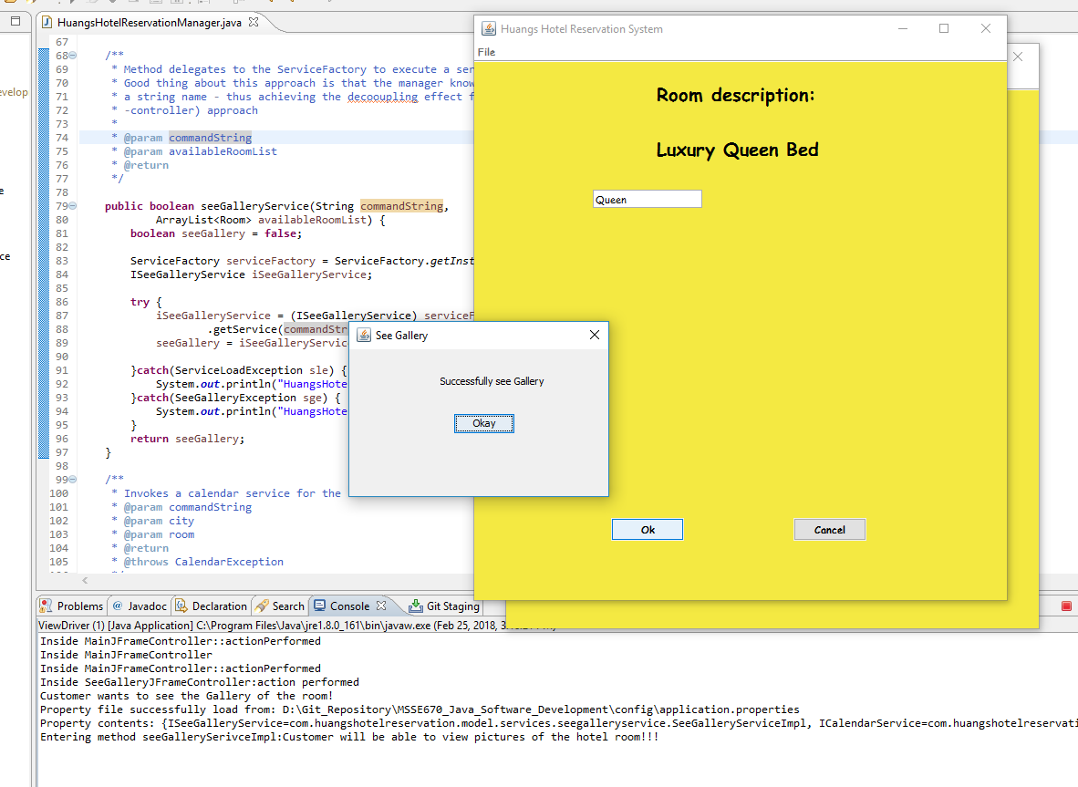

# Correction from HW5 – Review Request:

Fix comment 1 of HW5 – Review Request:

Refactor seeGalleryServiceImplTest.java -> SeeGalleryServiceImplTest.java

IseeGalleryService interface already properly cased:

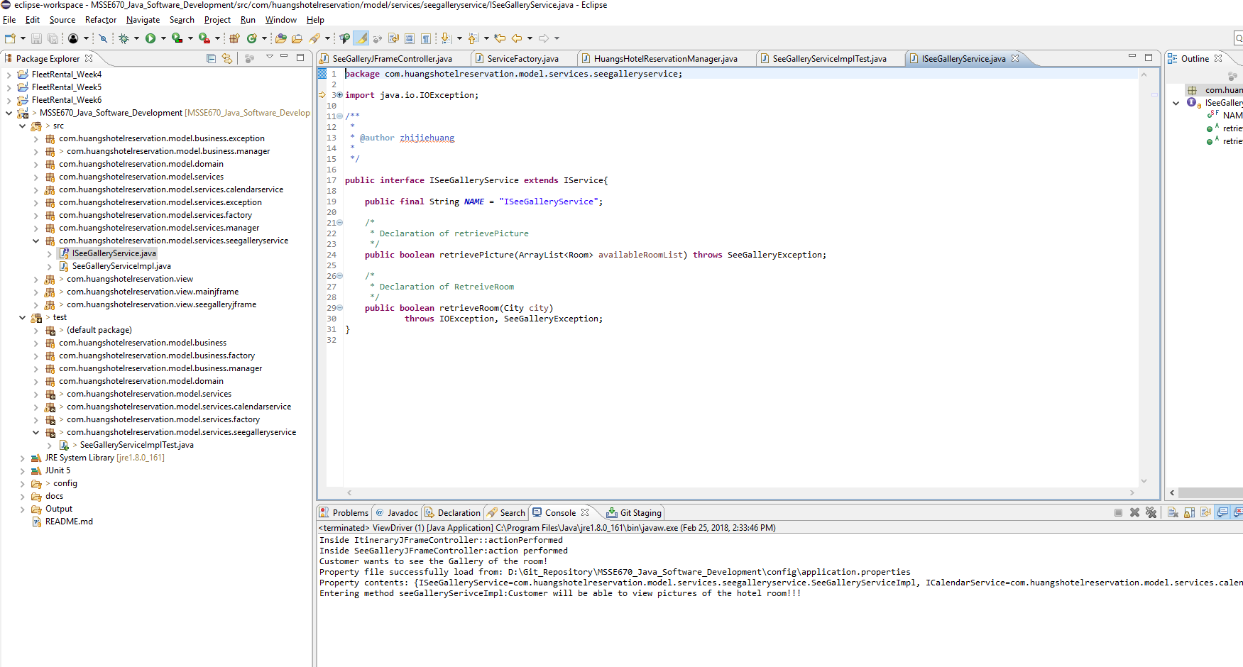

Fix comment 2 of HW5 – Review Request:

Refactor package com.huangshotelreservation.model.service.-> com.huangshotelreservation.model.services

So that there won’t be two service folders in the test directory.

Fix all like issues in my project.

Added all java docs to my class and variables.

Fix comment 3 of HW5 -Review Request:

retrieveRoom(City city) only throws SeeGalleryException. An exception should never propagated to the

business layer.

Fixed comment 4 in the test layer.

All should be properly cased.

# Correction from Week 5:

Fix comment 1 of Week5 HW Comments:

rename seeGalleryService to SeeGalleryService

Fix comment 2 of Week5 HW Comments:

Added comments to

Fix comment 3 of Week5 HW Comments:

Remove the main method from HuangsHotelReservationManager.java, test with Junit test instead.

Haven’t fix the oversimplified Unit case yet. Will try to fix it as soon as I can.

Fixed comment 5 from Week5 HW Comments:

Added all java docs and comments in the code.